KEGG_2021_Human
Retroviridae
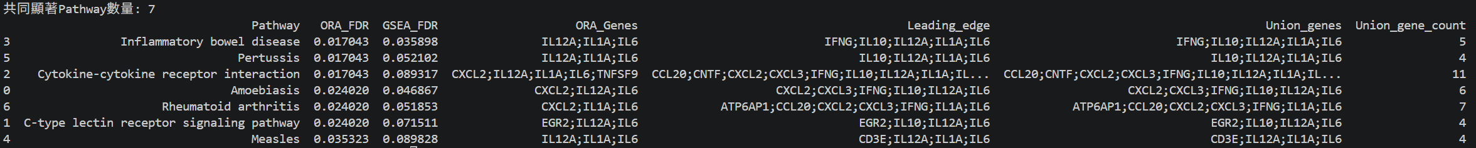

Reactome_2022
Retroviridae

GO_Biological_Process_2023
Picornaviridae

MSigDB_Hallmark_2020
Retroviridae

WikiPathways_2024_Human
Retroviridae
